Add a remote repository & Check remote repository

git remote add <origin (remote repository name)> <git repository url>

git remote -v



Push commits

git push -u origin master

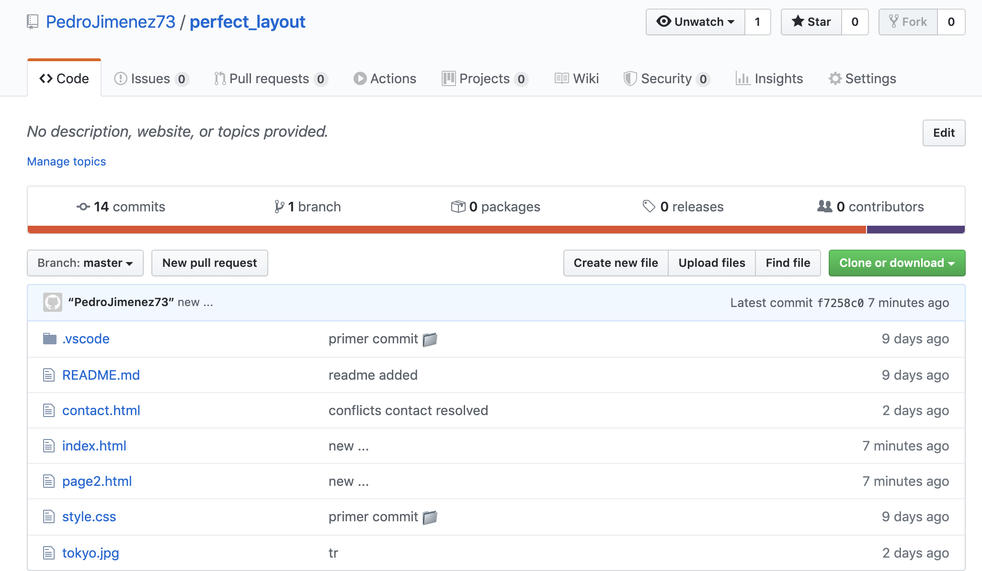

Push tags

git push --tags

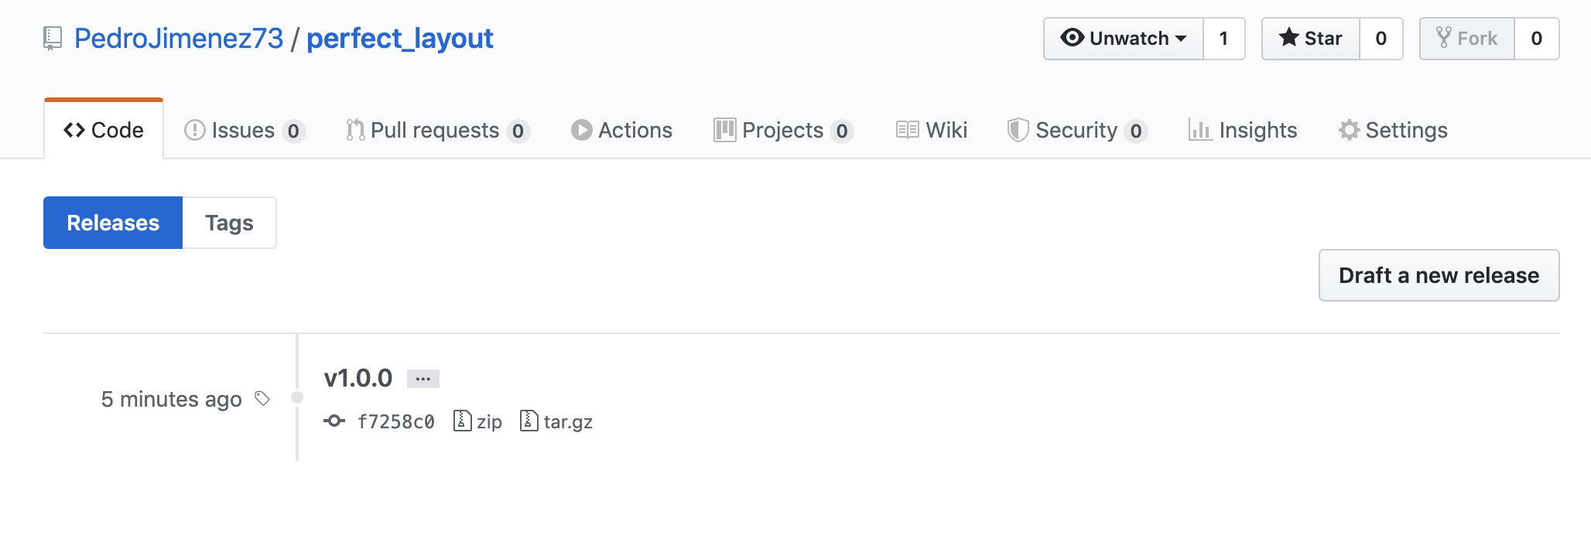

Commit Changes on Github.

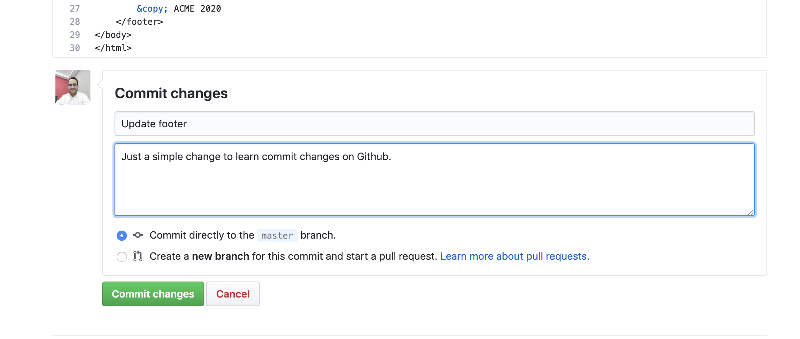

Pull from remote repository

git pull <origin> <master>

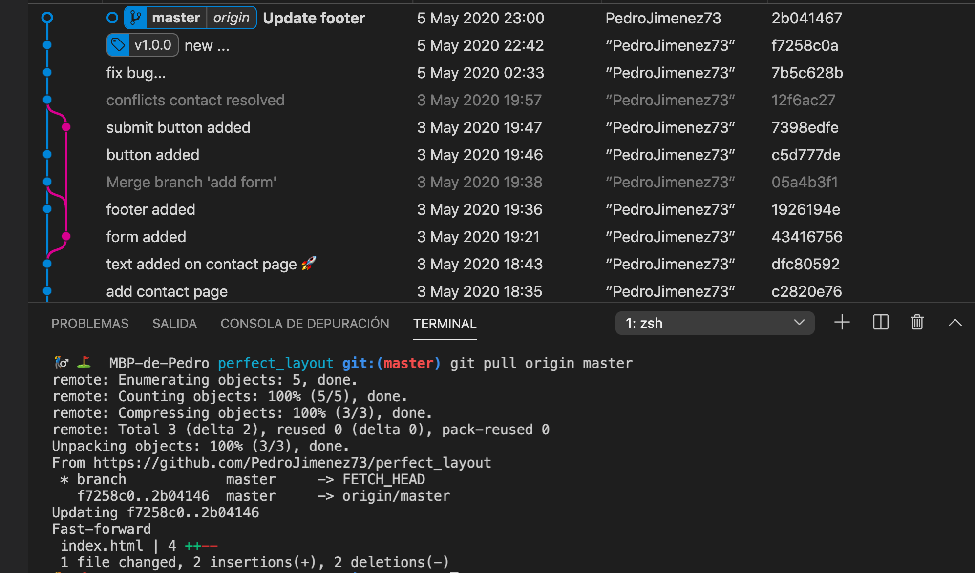

Note: Pull, make a merge with the commits changes from remote repository, if we don’t make this merge we can use ‘git fetch’ and later, when we check the changes, make a merge.

Clone a repository

git clone <remote repository url>